CASE STUDY

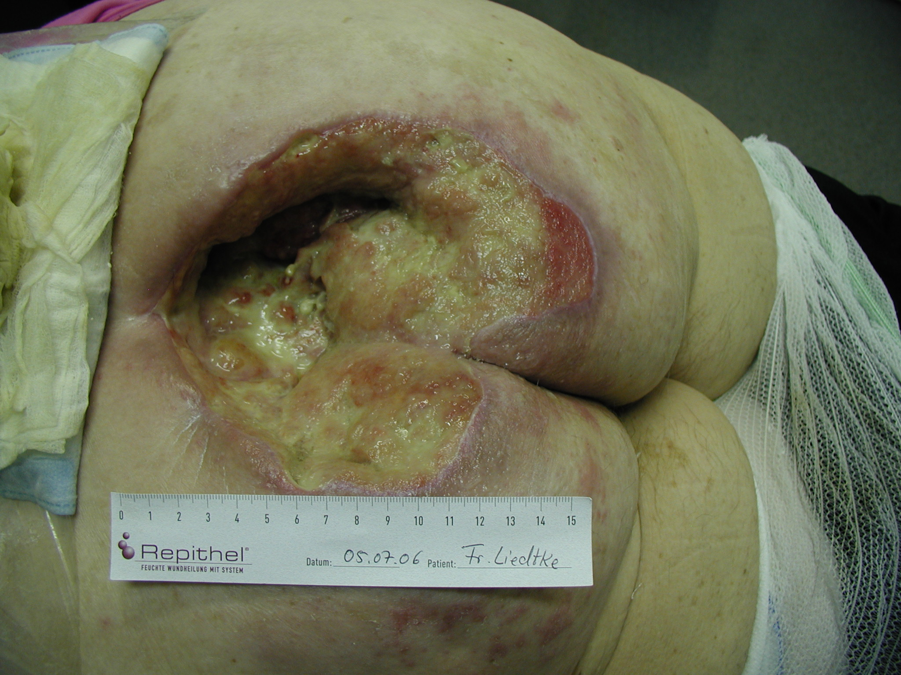
Figure 1 shows an 80-year old female patient
who developed a large infected decubitus ulcer
from a lengthy stay in a hospital bed following a
knee operation. She was treated with high dose
antibiotics. Surgeons recommended a colos-tomy and several operations to clean the wound.
Fearing she would pass away from the recommended surgical procedures, her family withdrew the patient from the hospital and took her to Dr. Richard Thiele for treatment with the DermaGold™ soft focused Multiwave™ device. Antibiotics were discontinued, and the patient was treated on an outpatient basis.
Figure 1
The patient received her first treatment on July 5, 2006.
The size of the wound prior to initial DermaGold treatment was 18 cm long x 15 cm wide x 8 cm deep. __________________________________________________________________________________

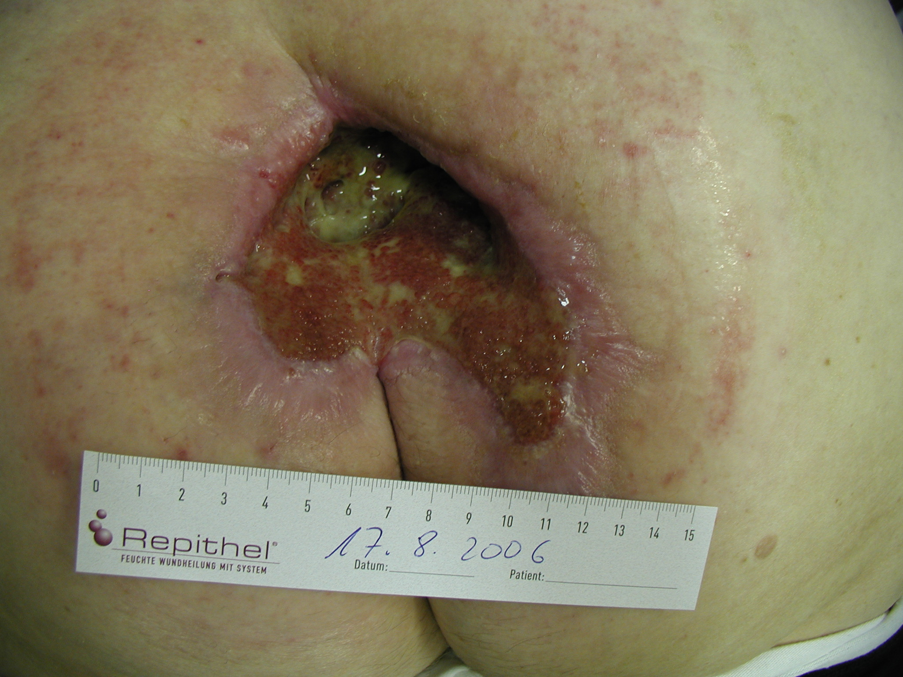
Dr. Thiele commenced weekly DermaGold treatments requiring no anesthesia and treatment times of approximately 10 minutes per week.

Figure 2 shows the patient 6 weeks after initial DermaGold treatment and prior to the 6th DermaGold treatment (August 17, 2006).

The size of the wound had decreased to 10 cm long x 8 cm wide x 6 cm deep (77% decrease).
New, healthy skin tissue is visible along the edges of the treatment site.
Figure 2
__________________________________________________________________________________

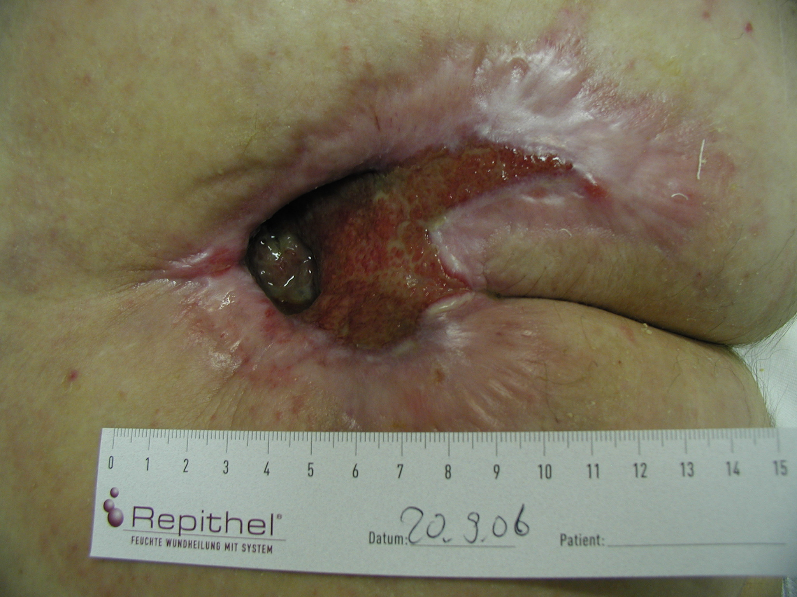
Figure 3 shows the patient on September 20, 2006, prior to the 11th weekly DermaGold treatment.

The size of the wound had decreased to 8 cm long x 6 cm wide x 5 cm deep (88% decrease).
New, healthy skin tissue continues to increase and fill in the wound site.

Figure 3

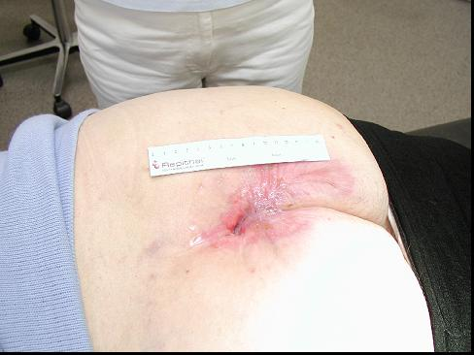
Figure 4 shows the patient on February 7,
2007, prior to the final DermaGold treatment.

The size of the wound had decreased to
1 cm long x 0.5 cm wide x 0.5 cm deep
(99.9% decrease).

Immediately following the final DermaGold treatment, the wound was closed sutures.

Figure 4

__________________________________________________________________________________

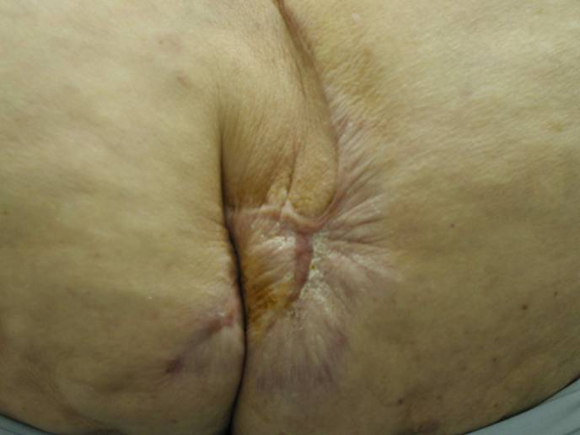
Figure 5 shows the patient in February 2008,
one year after final DermaGold treatment.

Figure 5

__________________________________________________________________________________

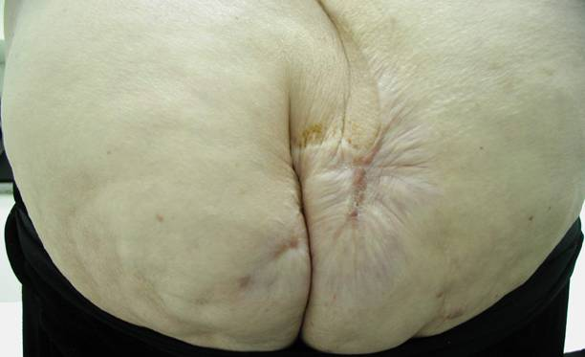
Figure 6 shows the patient in December 2008,
nearly 2 years after final DermaGold treatment.

Subsequent histologic examination showed full thickness, healthy skin (including hair follicles, sebaceous glands and other healthy tissue structures) with almost no scar tissue remaining.

Figure 6

